Cameron Palmer
Art 1300 – Art Appreciation
November 29, 2005
HBO Special – Diego Rivera

Diego Rivera, the man, the painter, the revolutionary.

Diego Rivera is considered one of the great 20th century painters and muralists. Drawing on the heritage of the Mexican indigenous styles of the Aztecs, he developed a style of art that spoke about his people and his politics.

This documentary should start off giving an opening narration of the artists’ early life. Then we follow with his revolutionary politics in his paintings, his relationship with Frida Kahlo, and follow with his end of life.

Early chronology of his life -
Diego Rivera was born December 13, 1886, in Guanajuato in Mexico, to Diego and Maria Barrientos Rivera. He lived in Guanajuato until 1892, when they moved to Mexico City. In 1896, at the age of 10, starts attending an evening art course at the Academy of San Carlos. In 1899, he becomes a full-time student at the Academy of San Carlos. In 1906, he is included in an exhibition at San Carlos and establishes himself as a painter.

Rivera moved to Europe in 1907, just before the 1910 Mexican Revolution. The Mexican Revolution overthrew Porfirio Diaz, a dictator. During the 10 year struggle for power various factions fought for power but ultimately the Communist ideology came to the forefront.

While in Europe he spends time in Barcelona, Spain, but then moved to Paris, France. Here he meets numerous influences that lead him into Cubism. He meets Modigliani, and others in the Montparnasse district of Paris. Montparnasse is a center of the Cubist movement and develops his cubist style between 1913 and 1918. Some of the other notables from this movement are Picasso, Braque, and Cezanne.

In 1921, Rivera returns to Mexico.

It is in Mexico that Rivera embraces the mural style that people recognize, and his themes become that of revolution and an ideal Mexican society. The mural painting has its roots in the style of the ancient Mexican cities like Teotihuacan. Rivera, and his friends, known as Los Tres Grandes, make a compact called “A Declaration of Social, Political and Aesthetic Principles.“ In it they declare, “We repudiate easel painting and all ultra-intellectual, drawing room art, as aristocratic, and we uphold the manifestations of monumental art because of its public usefulness.”
An example of this idealized history is his 1930 piece entitled History of Mexico. In it Rivera depicts the honest hard working people of Mexico using a realist and cubist style.

These images, The Flower Carrier, and Flower Vendor, show not only the indigenous people of Mexico as hard workers, but workers possibly struggling under a burden not unlike that of Atlas in ancient times. Carrying the world on their backs. This fits in with the Communist ideology because it is the worker who is celebrated as the builder of this world. Much like the Controller of the Universe mural, these people, not men in suits, are shaping a better tomorrow from the sweat of their brow.

During Rivera’s extended tour of the United States he received a commission from Nelson Rockefeller to provide a mural for their project, the Rockefeller Center. The painting entitled, “Man at crossroads looking with hope and high vision to the choosing of a new and better future” was to be 63 feet by 17 feet.

The mural depicted a central figure, clad in the clothes of construction or a mill worker operating the controls of the future. A great apparatus of amazing complexity powers a pair of wings that cross behind the man and are painted with Science and Space imagery, and beneath him the plants or the earth. Showing that man was on the brink of total mastery of the Earth through its growing seasons, space and our knowledge of it, and science understanding cells and the inner workings of living things, including ourselves.

To the right is Vladimir Lenin clasping the hands and uniting a black man, a baby, a soldier and others. Showing that while the United States liked to think of itself as the land of the free, only Socialism, and Communism set people free without concerns of race, occupation or ethnicity. This in a time when the United States still actively engaged in discrimination and segregation. Futher to the right one can also pick out Leon Trotsky, a long time friend of Rivera, and further right Marx and Engels. The counterpoint to Lenin is a room full of white aristocratic or bourgeoisie people playing cards who obviously have little to offer the future. To the left and right of the central figure are two great lenses, most likely representing how we see outer-space and inner-space, through which the people on the left and right view this future.

In the bottom left portion of the painting is a monkey holding the hand of a baby, near an old white-bearded man that is obviously Darwin. This is yet another example of the scientific awareness of man. Of course receding into the past, or the background of this mural are the gas-masked soldiers of World War I, and on the right the proletariat fighting for their rights against the Tsar of Russia. On the right and left of the painting are broken Greek statues one depicting a Zeus like figure wearing a rosary around his neck. This could represent the angry Christian god throwing lightening down with his broken arm only to be harnessed by man’s machines.

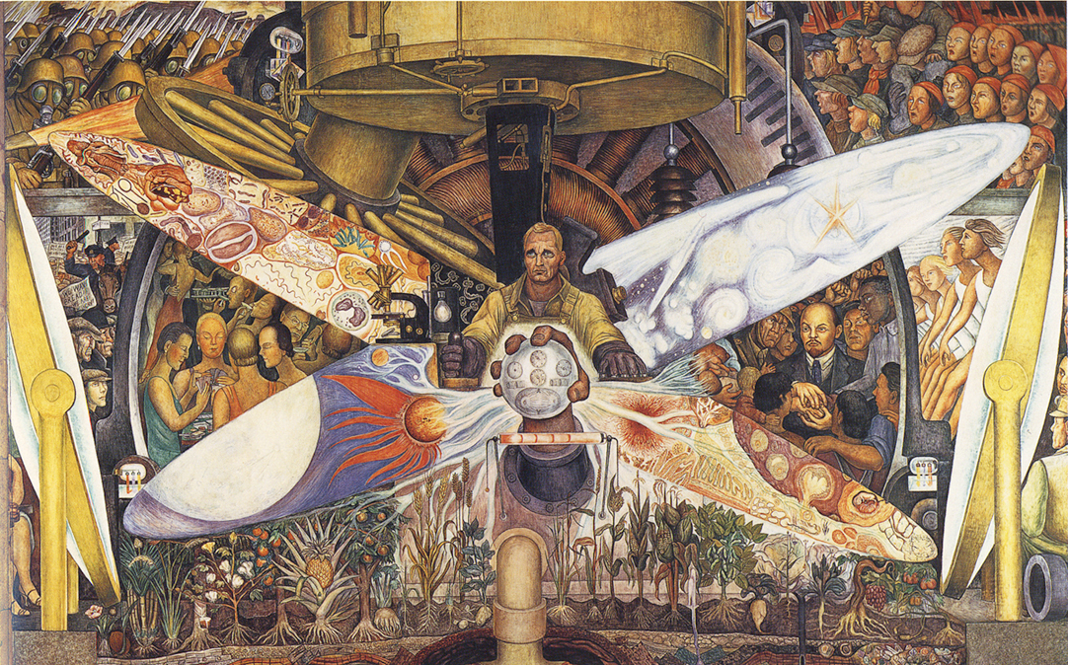
Man, Controller of the Universe, Palace of Fine Arts, Mexico City

May 22, 1933 Rivera was called down form the scaffold and handed the balance of his fee and dismissed. It was the depiction Lenin that caused the great controversy over this mural, and led to it’s covering over with wood and tarpaper. Rivera was asked to remove Lenin from the painting, and his subsequent refusal that led to it being torn down. Our only pictures of the original unfinished piece were smuggled out by one of Rivera’s assistants. Rivera recreated the piece at the Palace of Fine Arts, Mexico City where it was named “Man, Controller of the Universe”, in 1934.

I think this painting alone could be a major focus of the documentary with a reenactment of the scene between Rivera and the Rockefeller, the subsequent disagreement, and removal. It is certainly a dramatic moment in his life and would play well with audiences.

It would be useful after discussing the controversy created by this painting to backup and show his involvement in the Mexican Communist movement. The exiled Trotsky character initially lived with Rivera. His life is threatened from afar by Stalin. Apparently he had fallen out of favor with Stalin and a price was put on his head. Several assassination attempts are made against his life, one of the would-be assassins was David Alfaro Siqueiros, one of the Tres Grandes. In the end, they got him with a ice pick to the head. Trotsky stopped his bodyguards from killing him saying, “This is a man with a story to tell.” After the death of Trotsky in 1940, Rivera became an anti-Stalinist.

Another moment of the documentary would be his love life. Diego Rivera had numerous affairs, and wives. The most famous relationship was with Frida Kahlo. He was instrumental in getting her accepted in the Mexican art world and considered her one of the greatest female artists. Though they divorced, they soon reconciled and a year before her death he said, “She is the greatest Mexican artist.”

Totonac Civilization, 1950, National Palace, Mexico City

About a year before his death, on his 70th birthday, he received a national honor.
Diego Rivera died in 1957 in his studio of heart failure.

I think his story is worthy of a documentary because he is such an interesting character, and a great painter. He was alive during a very tumultuous time in the world. Nations were undergoing social and political revolutions and he channeled this into his art. With the recent success of the Frida Kahlo movie starring Selma Hayek, there will be a lot of people interested in this documentary so they can learn another aspect of the story, told in a more formal and academic way.

